
Name: MURAM SIDDHARDHA REDDY
Semester: 2nd Semester,
School of Computer Engineering
Institution: MIT MANIPAL
Date: 9th January 2026
Miniaturized Satellite Formats Used in Space Engineering and Education

PARIKSHIT TAKS-2



Abstract of the Report

Miniature satellites greatly enhance access to space technology and education, primarily due to their significantly low costs, reduced complexity, and fewer barriers to entry for student and academic projects. This report, titled “Miniaturized Satellite Formats Used in Space Engineering and Education,” will explore various formats of miniaturized space vehicles, including CubeSats, CanSats, FlatSats, PocketQubes, and other picosatellite variants. It will detail how these satellites are utilized in engineering practice and educational settings. The report highlights the structure, applications, educational value, and real-world examples associated with each format.

Table of Contents

Introduction

CubeSat

CanSat

FlatSat

PocketQube and Other Picosatellites

Case Studies / Examples

Educational Roles and Benefits

Conclusion

References

Introduction
A miniature satellite is defined as a satellite that is low in mass and size, typically weighing less than 1,200 kg. These small satellites offer a way to significantly reduce the high economic costs associated with launch vehicles and construction. However, even small satellites face challenges, such as limited power storage and the need for effective propulsion systems.

The smaller scale of these satellites allows for more affordable designs and easier mass production. Additionally, they enable missions that larger satellites may not be able to accomplish. Miniature satellites are mainly utilized for research purposes at universities around the world, providing students the opportunity to design, build, test, and operate functional spacecraft systems.

CubeSat
CubeSats represent a class of miniature satellites designed around a standardized size and form factor. The standard CubeSat size is defined as “one unit,” measuring 10 cm x 10 cm x 10 cm, with the option to scale up to larger dimensions. Developed initially in 1999 by California Polytechnic State University at San Luis Obispo and Stanford University, CubeSats were created to serve as a platform for education and space exploration. Today, they provide a cost-effective platform for scientific investigations, technology demonstrations, and advanced mission concepts, including constellations, swarms, and disaggregated systems. The evolution of CubeSats has fostered the creation of its own industry, with ongoing collaboration among government, industry, and academia to enhance their capabilities.

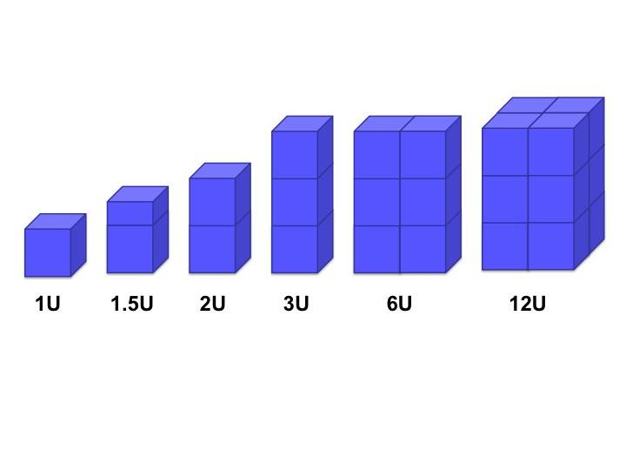
Figure 1. CubeSats visualization based on sizes

FlatSat

A FlatSat is not a satellite designed for space travel; rather, it serves as a ground-based engineering testbed that simulates the electronics and subsystems of a satellite, often a CubeSat, in a tabletop configuration. The primary purpose of a FlatSat is for testing, integration, and debugging of satellite subsystems. It operates under typical lab conditions and is ideal for learning about system integration and debugging processes.

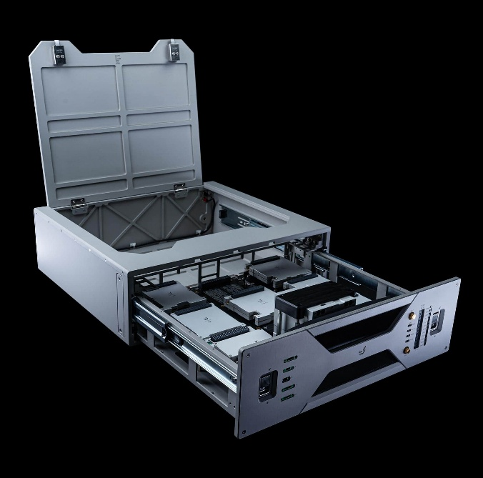
Figure 2. FlatSat

PocketQube and Other Picosatellites

- A PocketQube is a miniaturized satellite format with dimensions of 5×5×5 cm (1p unit) and a mass of up to approximately 250 g.
- Its compact size and simplicity provide a highly accessible platform for student space missions.
- PocketQubes have been successfully launched by universities and hobbyists to conduct basic measurements and amateur radio experiments.

PocketCubes stand out from CubeSats in several fascinating ways, including their size, volume, mass limitations, cost, and the variety of applications they can serve. This unique miniaturization opens up exciting possibilities for space exploration and technology!

**Other Picosatellites and ThinSats**
ThinSat is an innovative satellite design that utilizes a compact, flat format based on PocketQube standards, making it ideal for educational and research purposes. Its slim configuration facilitates easier deployment and integration into various projects, enhancing hands-on learning.

The field of ultra-small satellites is also evolving with femtosatellites and experimental microchips. While still in the experimental phase, these technologies hold intriguing potential for future advancements in miniature satellite systems and scientific exploration.

Conclusion

Miniaturized satellite formats such as CubeSats, CanSats, FlatSats, PocketQubes, and other picosatellites have transformed space education and engineering. They make complex space systems accessible, practical, and affordable, enabling students to work on real aerospace projects. Their continued development fosters innovation, expands STEM education, and prepares the next generation of space professionals.

References

- https://en.wikipedia.org/wiki/Small_satellite ( Wikipedia)
- https://www.nasa.gov/ (NASA Webpage)
- https://andoyaspace.no/

